**(Step 5.1 - Update the data dictionary and list of assumptions (as needed).**

**Step 5.2 Write and execute SQL statements to create all the tables needed to implement the design.**

CREATE TABLE InsurancePolicy (

policyNo NUMBER(9) NOT NULL PRIMARY KEY,

company VARCHAR2(30),

insuredName VARCHAR2(50),

policytype CHAR(1),

medicalCoPay NUMBER(9, 2),

labCoPay NUMBER(9, 2),

pharmacyCoPay NUMBER(9, 2),

startDate DATE,

endDate DATE

);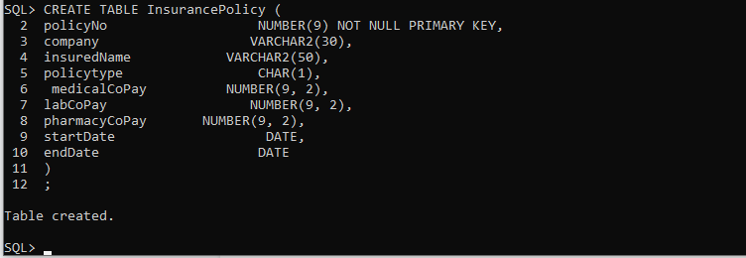

CREATE TABLE Patient(

patientNo NUMBER(9) NOT NULL PRIMARY KEY,

name VARCHAR2(30) NOT NULL,

address VARCHAR2(50),

phone CHAR(10),

dateOfBirth DATE,

Sex CHAR(1),

insuranceCo VARCHAR2(30),

policyNo NUMBER(9),

relationshipToInsured CHAR(10) NOT NULL,

CONSTRAINT Patient_policyNo_fk FOREIGN KEY (policyNo) REFERENCES InsurancePolicy (policyNo)

);

CREATE UNIQUE INDEX Patient_policyNo_i ON Patient(policyNo);

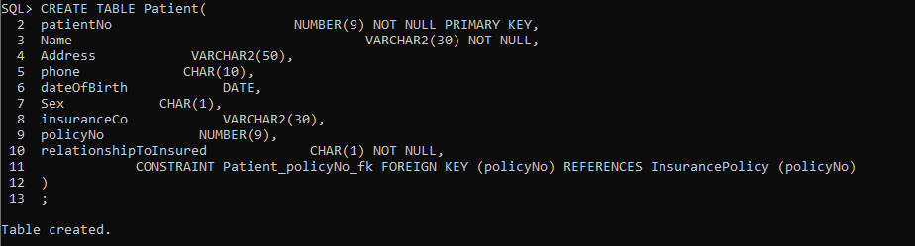

CREATE TABLE Staff (

staffNo NUMBER(9) NOT NULL PRIMARY KEY,

name VARCHAR2(30) NOT NULL,

title VARCHAR2(4) NOT NULL,

specialty VARCHAR2(30) NOT NULL,

address VARCHAR2(50),

phone CHAR(10),

);

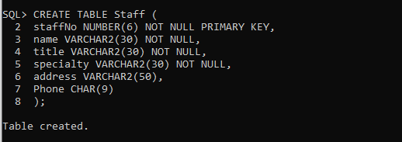

CREATE TABLE Availability (

staffNo NUMBER(9) NOT NULL,

availDate DATE NOT NULL,

startTime    VARCHAR2(8),

endTime      VARCHAR2(8),

CONSTRAINT Availability_staffNo_availDate_pk PRIMARY KEY (staffNo, availDate),

CONSTRAINT Availability_staffNo_fk FOREIGN KEY (staffNo) REFERENCES Staff (staffNo)

);

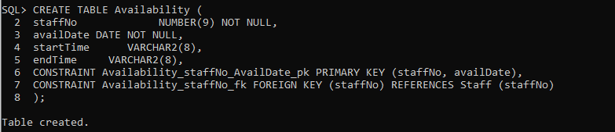

CREATE TABLE Room (

roomNo NUMBER(3) NOT NULL PRIMARY KEY,

roomType CHAR(1),

condition VARCHAR2(50)

);

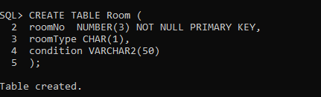

CREATE TABLE Visit (

visitNo NUMBER(9) NOT NULL,

patientNo NUMBER(9) NOT NULL,

visitdate DATE,

visittime VARCHAR2(30),

duration NUMBER(2),

reason VARCHAR2(100),

visitType VARCHAR2(30),

visitCost NUMBER(3,2),

staffNo NUMBER(9) NOT NULL,

roomNo NUMBER(3) NOT NULL,

CONSTRAINT Visit_visitNo_pk PRIMARY KEY (visitNo),

CONSTRAINT Visit_patientNo_fk FOREIGN KEY (patientNo) REFERENCES Patient(patientNo) ON DELETE CASCADE,

CONSTRAINT Visit_roomNo_fk FOREIGN KEY (roomNo) REFERENCES Room(roomNo) ON DELETE CASCADE

);

CREATE UNIQUE INDEX Visit_patientNo_i ON Visit(patientNo);

CREATE UNIQUE INDEX Visit_roomNo_i ON Visit(roomNo);

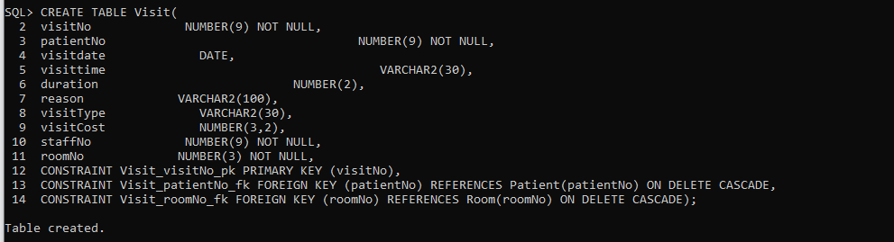

CREATE TABLE Appointment (

patientNo NUMBER(9) NOT NULL,

apptdate DATE NOT NULL,

appttime VARCHAR(30) NOT NULL,

Reason VARCHAR2(50),

staffNo NUMBER(9) NOT NULL,

visitNo NUMBER(9),

CONSTRAINT Appointment_patientNo_apptdate_pk PRIMARY KEY (patientNo, apptdate),

CONSTRAINT Appointment_patientNo_fk FOREIGN KEY (patientNo) REFERENCES Patient(patientNo) ON DELETE CASCADE,

CONSTRAINT Appointment_staffNo_fk FOREIGN KEY (staffNo) REFERENCES Staff(staffNo) ON DELETE CASCADE,

CONSTRAINT Appointment_visitNo_fk FOREIGN KEY (visitNo) REFERENCES Visit(visitNo) ON DELETE CASCADE

);

CREATE UNIQUE INDEX Appointment_patientNo_i ON Appointment(patientNo);

CREATE UNIQUE INDEX Appointment_staffNo_i ON Appointment(staffNo);

CREATE UNIQUE INDEX Appointment_visitNo_i ON Appointment(visitNo);

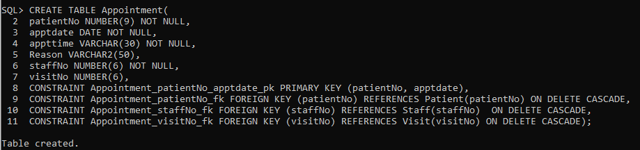

CREATE TABLE Referral (

refNo NUMBER(6) NOT NULL PRIMARY KEY,

visitNo NUMBER(6) NOT NULL,

refTo VARCHAR2(30),

Reason VARCHAR2(50),

CONSTRAINT Referral_visitNo_fk FOREIGN KEY (visitNo) REFERENCES Visit(visitNo) ON DELETE CASCADE

);

CREATE UNIQUE INDEX Referral_visitNo_i ON Referral(visitNo);

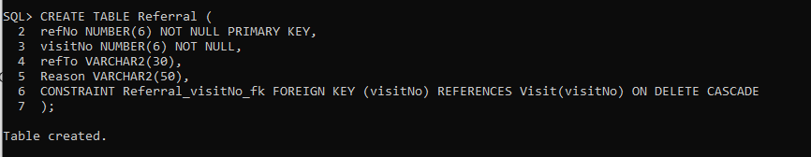

CREATE TABLE Bill (

invoiceNo NUMBER(9) NOT NULL PRIMARY KEY,

billDate DATE ,

totalAmount NUMBER(9, 2),

dueDate DATE,

patientNo NUMBER(9) NOT NULL,

amountPaid NUMBER(9, 2),

CONSTRAINT Bill_patientNo_fk FOREIGN KEY (patientNo) REFERENCES Patient(patientNo) ON DELETE CASCADE

);

CREATE INDEX Bill_patientNo_i ON Bill(patientNo);

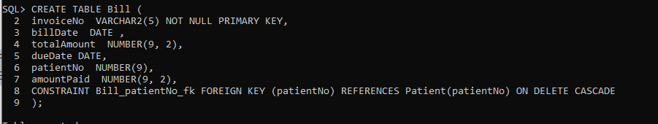

CREATE TABLE Charge (

invoiceNo NUMBER(9) NOT NULL,

serviceType VARCHAR2(50) NOT NULL,

serviceDate DATE NOT NULL,

amountCharged NUMBER(9, 2),

CONSTRAINT Charge_invoiceNo_serviceType_serviceDate_pk PRIMARY KEY(invoiceNo, serviceType, serviceDate),

CONSTRAINT Charge_invoiceNo_fk FOREIGN KEY (invoiceNo ) REFERENCES Bill(invoiceNo) ON DELETE CASCADE

);

CREATE UNIQUE INDEX Charge_invoiceNo_i ON Charge(invoiceNo);

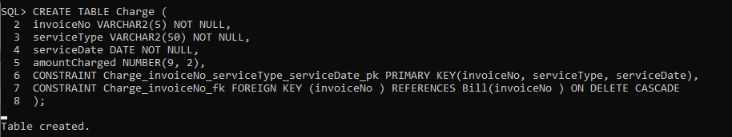

CREATE TABLE Payment (

invoiceNo NUMBER(9) NOT NULL,

datePaid DATE NOT NULL,

amountPaid         NUMBER(7,2),

patientPayer NUMBER(9),

insuranceCompany VARCHAR2(25),

policyNo NUMBER(9),

CONSTRAINT Payment_invoiceNo_date_pk PRIMARY KEY(invoiceNo, datePaid),

CONSTRAINT Payment_invoiceNo_fk FOREIGN KEY(invoiceNo) REFERENCES Bill(invoiceNo),

CONSTRAINT Payment_patientPayer_fk FOREIGN KEY(patientPayer) REFERENCES Patient(patientNo),

CONSTRAINT Payment_insCo_polNo_fk FOREIGN KEY(policyNo) REFERENCES InsurancePolicy(policyNo)

);

CREATE UNIQUE INDEX Payment_invoiceNo_i ON Payment(invoiceNo);

CREATE UNIQUE INDEX Payment_patientPayer_i ON Payment(patientPayer);

CREATE UNIQUE INDEX Payment_policyNo_i ON Payment(policyNo);

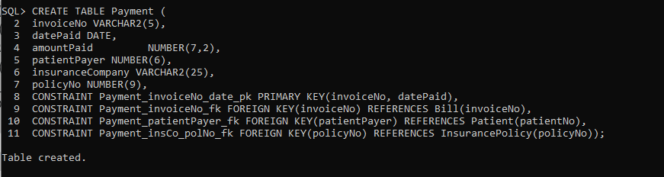

CREATE TABLE DiagnosisMenu (

diagCode CHAR(6),

diagName VARCHAR2(50),

CONSTRAINT DiagnosisMenu_diagCode_pk PRIMARY KEY (diagCode));

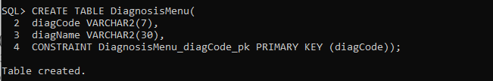

CREATE TABLE ProcedureMenu (

procCode CHAR(6) NOT NULL,

procName VARCHAR2(50),

cost NUMBER(10,2),

CONSTRAINT ProcedureMenu_procCode_pk PRIMARY KEY (procCode));

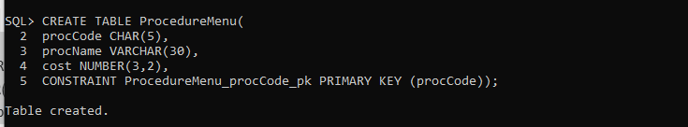

CREATE TABLE PrescriptionScript (

scriptNo NUMBER(9),

visitNo NUMBER(9),

dateWritten DATE,

itemPrescribed VARCHAR(30),

quanityPrescribed NUMBER(2),

Directions VARCHAR(50),

numberRefills NUMBER(2),

CONSTRAINT PrescriptionScript_scriptNo_pk PRIMARY KEY (scriptNo),

CONSTRAINT PrescriptionScript_visittNo_fk FOREIGN KEY (visitNo) REFERENCES Visit(visitNo)

);

CREATE INDEX PrescriptionScript_visitNo_i ON PrescriptionScript(visitNo);

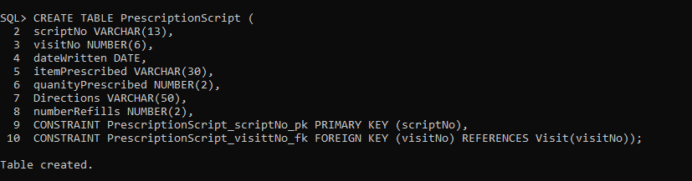

CREATE TABLE PrescriptionMedication (

RXNumber NUMBER(9) NOT NULL PRIMARY KEY,

scriptNo NUMBER(9),

drugDispensed VARCHAR2(30),

dateDispensed DATE,

quantityDispensed NUMBER(3),

refillsRemaining NUMBER(2),

Cost NUMBER(10,2),

CONSTRAINT PrescriptionMedication_scriptNo_fk FOREIGN KEY (scriptNo) REFERENCES prescriptionScript(scriptNo)

);

CREATE UNIQUE INDEX PrescriptionMedication_scriptNo_i ON PrescriptionMedication(scriptNo);

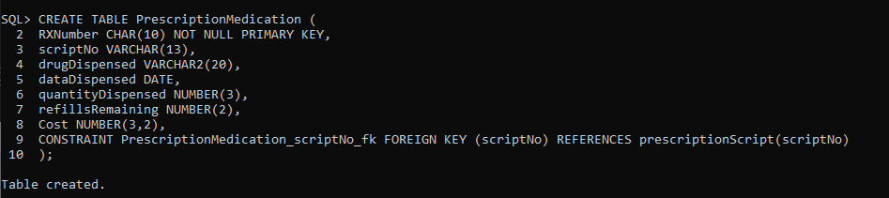

CREATE TABLE LabTest (

testNo NUMBER(9) NOT NULL,

RXNumber NUMBER(9) NOT NULL,

testType CHAR(1),

testDate DATE,

testTime VARCHAR2(30),

cost NUMBER(9,2),

result VARCHAR2(30),

CONSTRAINT LabTest_testNo_pk PRIMARY KEY (testNo),

CONSTRAINT LabTest_RXNumber_fk FOREIGN KEY (RXNumber) REFERENCES PrescriptionMedication(RXNumber) ON DELETE CASCADE

);

CREATE UNIQUE INDEX LabTest_RXNumber_i ON LabTest (RXNumber);

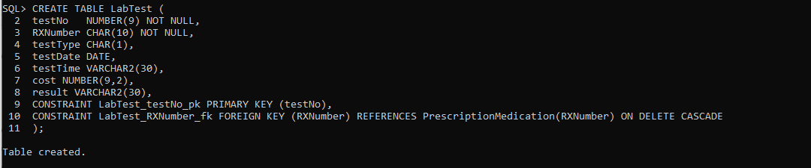

CREATE TABLE ProcedurePerformed (

visitNo NUMBER(6) NOT NULL,

procCode CHAR(6) NOT NULL,

result VARCHAR2(50),

CONSTRAINT ProcedurePerformed_visitNo_procCode_pk PRIMARY KEY (visitNo, procCode),

CONSTRAINT ProcedurePerformed_visitNo_fk FOREIGN KEY(visitNo) REFERENCES Visit(visitNo),

CONSTRAINT ProcedurePerformed_procCode_fk FOREIGN KEY(procCode) REFERENCES ProcedureMenu(procCode));

CREATE INDEX ProcedurePerformed_procCode_i ON ProcedurePerformed(procCode);

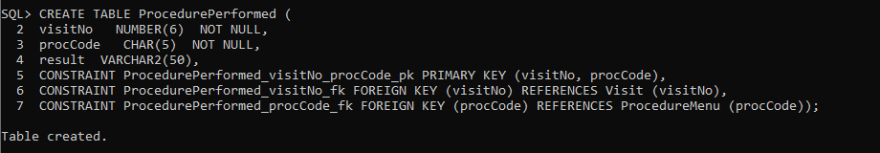

CREATE TABLE Diagnosis (

visitNo NUMBER(6) NOT NULL,

diagCode CHAR(6) NOT NULL,

dateOnset DATE,

symptoms VARCHAR2(50),

Severity NUMBER(2),

Prognosis VARCHAR(50),

CONSTRAINT Diagnosis_visitNo_diagCode_pk PRIMARY KEY(visitNo, diagCode),

CONSTRAINT Diagnosis_visitNo_fk FOREIGN KEY (visitNo) REFERENCES Visit (visitNo),

CONSTRAINT Diagnosis_diagCode_fk FOREIGN KEY (diagCode) REFERENCES DiagnosisMenu (diagCode));

CREATE UNIQUE INDEX Diagnosis_visitNo_i ON Diagnosis (visitNo);

CREATE UNIQUE INDEX Diagnosis_diagCode_i ON Diagnosis (diagCode);

